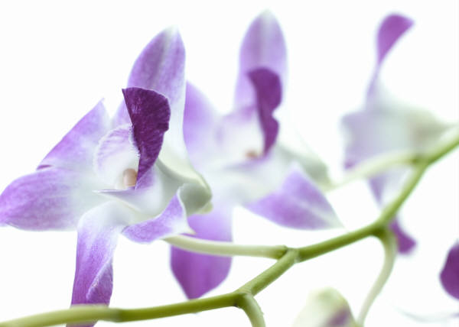

**Thank you for sharing this special time with me**

**Thank you for sharing this special time with me**

**Tara**

**Kali**



**Melina**

**Jessica**

**Thank you for sharing this special time with me**

**Thank you for sharing this special time with me**



**Kaily**

**Jaimie**

**Thank you for sharing this special time with me**

**Thank you for sharing this special time with me**



**Jasmin**

**Thank you for sharing this special time with me**

**Thank you for sharing this special time with me**