They lived happily ever after!



Thank you for coming to our wedding!

C:\Users\Kim\AppData\Local\Microsoft\Windows\Temporary Internet Files\Content.IE5\IX1CYON5\MC900020728[1].wmf

j0151057

You’re invited to Kim and Kevin’s wedding!

Draw your favorite part of the day!



Bride and Groom

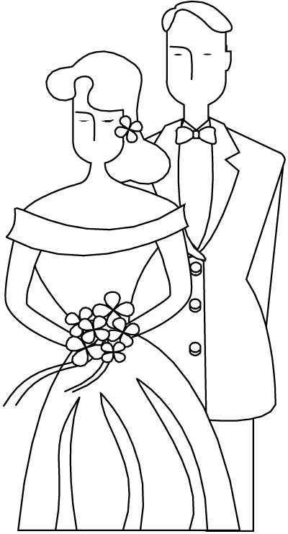

Ding Dong

MCj03557490000[1]

Color the wedding bells in your favorite color

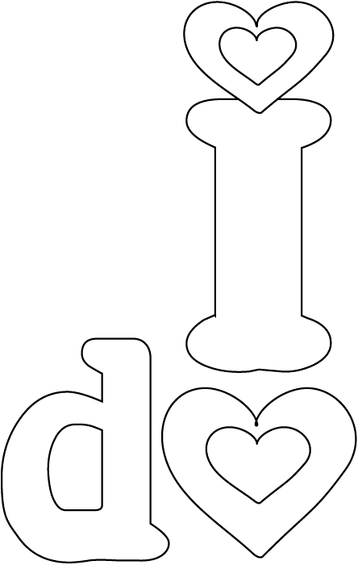

Draw a line from one column to the other to match the wedding pictures.





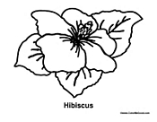 

~All you need is love~

Help the groom find his bride!

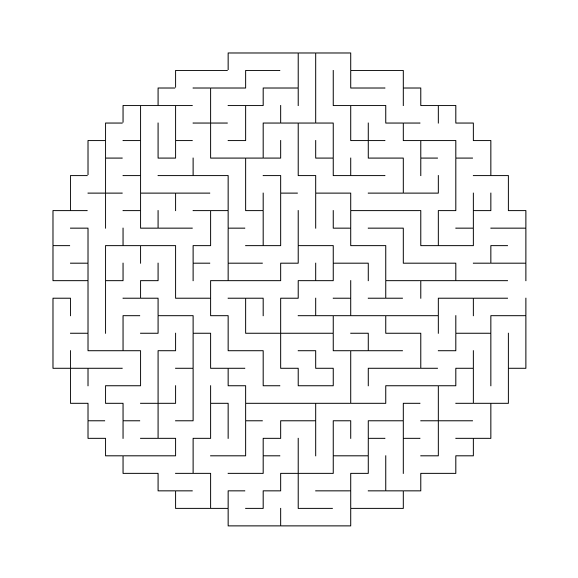 C:\Users\Kim\AppData\Local\Microsoft\Windows\Temporary Internet Files\Content.IE5\6S28SUBE\MC900212073[1].wmf

C:\Users\Kim\AppData\Local\Microsoft\Windows\Temporary Internet Files\Content.IE5\TQF6N1UN\MC900310172[1].wmf



Let’s eat some cake!

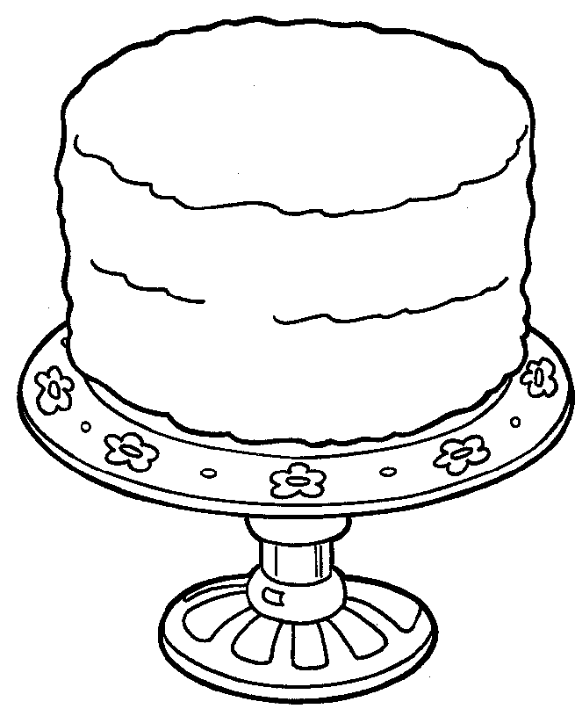

Boogie Down!

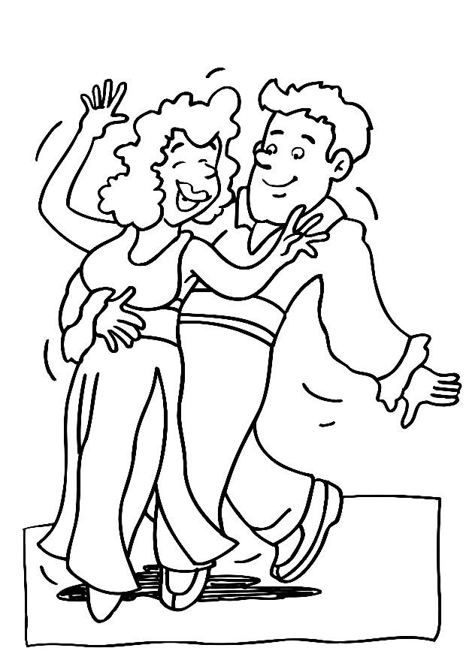

Wedding Word Search

|  |  |  |  |  |  |  |  |  |  |  |  |  |  |  |
| --- | --- | --- | --- | --- | --- | --- | --- | --- | --- | --- | --- | --- | --- | --- |
| M | W | E | J | X | M | B | O | W | L | E | H | Y | O | J |
| N | U | D | G | O | J | R | U | R | D | V | E | S | Q | P |
| G | P | S | X | H | W | W | I | I | C | Y | R | J | T | G |
| G | S | U | I | H | D | G | R | A | E | D | O | E | B | A |
| D | Y | O | H | C | R | B | K | E | R | O | Q | Q | U | Y |
| G | M | E | H | E | T | E | Q | B | E | R | S | U | X | U |
| S | R | C | W | G | M | F | C | C | M | A | M | U | W | P |
| C | Y | O | H | U | N | U | C | I | O | P | V | E | Z | R |
| A | L | X | B | A | Z | I | G | T | N | Z | D | R | W | I |
| F | G | R | O | O | M | U | C | T | Y | D | N | E | I | N |
| S | L | H | N | M | H | P | Q | N | I | D | F | N | P | G |
| T | E | U | Q | U | O | B | A | N | A | E | I | N | M | T |
| I | G | U | T | P | Q | Z | G | G | B | D | J | I | U | K |
| K | U | O | M | G | Y | V | Q | J | N | M | D | D | F | G |
| R | E | C | E | P | T | I | O | N | C | E | S | W | O | V |

BOUQUET BRIDE CAKE

CEREMONY CHAMPAGNE DANCING

DINNER FLOWERGIRL GROOM

MUSIC RECEPTION RING

VOWS WEDDING LOVE